**Human-Computer Interaction (HCI)**

|  |
| --- |
| Assignment – 1 |
| **Submitted By**  Name: Sumonta Saha Mridul  Reg No: 2019831056 |

**Human-Computer Interaction (HCI) guidelines:**

|  |  |
| --- | --- |
| Guideline Name | Rating |
| * Avoid cluttered displays: | Rating: 8/10 |
| * Place important items at the top center: | Rating: 10/10 |
| * Place important items consistently: | Rating: 9.5/10 |
| * Set appropriate page lengths: | Rating: 8/10 |
| * Minimal input actions by the user: | Rating: 9/10 |
| * Make all functionality available from a keyboard: | Rating: 2/10 |
| * Clear and effective labeling of buttons and data-entry fields: | Rating: 9/10 |
| * Compatibility of data entry with data display: | Rating: 9/10 |
| * Do not use content that causes seizures: | Rating: 1/10 |
| * Give users enough time to read and use content: | Rating: 10/10 |
| * Design of form and dialog boxes: | Rating: 9/10 |
| * Help users navigate and find content: | Rating: 6/10 |
| * Help users navigate and find content: | Rating: 9/10 |
| * Maximize compatibility with current and future user tools: | Rating 9/10 |

1. **Avoid cluttered displays:*Rating: 8/10***
   1. Clear Visual Hierarchy (Enough Spaces Remove Congested and clutterers)
   2. **2 Point Cut**: Website Design in Home Screen does overwhelm users with some extra information that user doesn’t need in a single screen

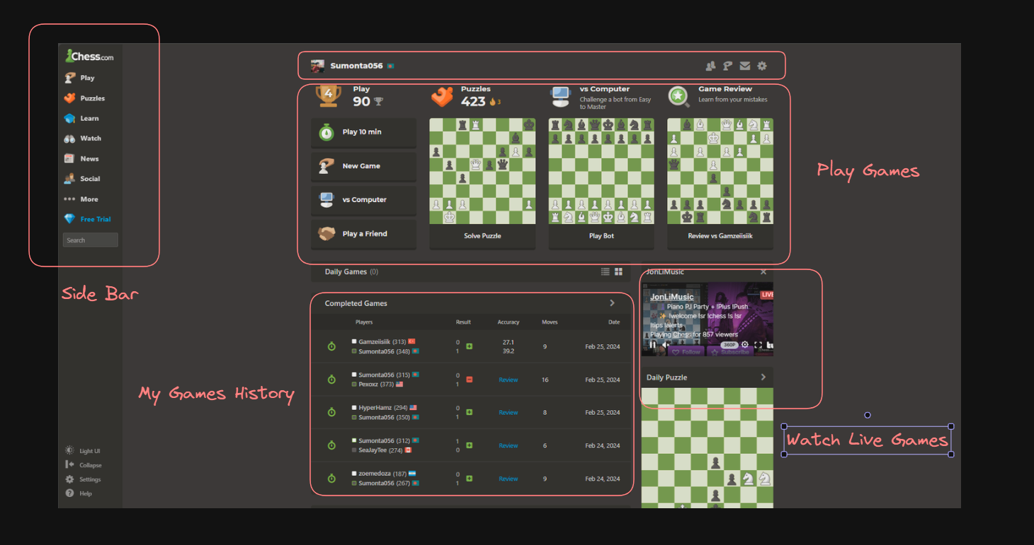

1. **Place important items at the top center: *Rating: 10/10***
   1. Home Screen and All-Important element are Centered
   2. Main Game Also is on Top Centered of Screen and easy to visualize

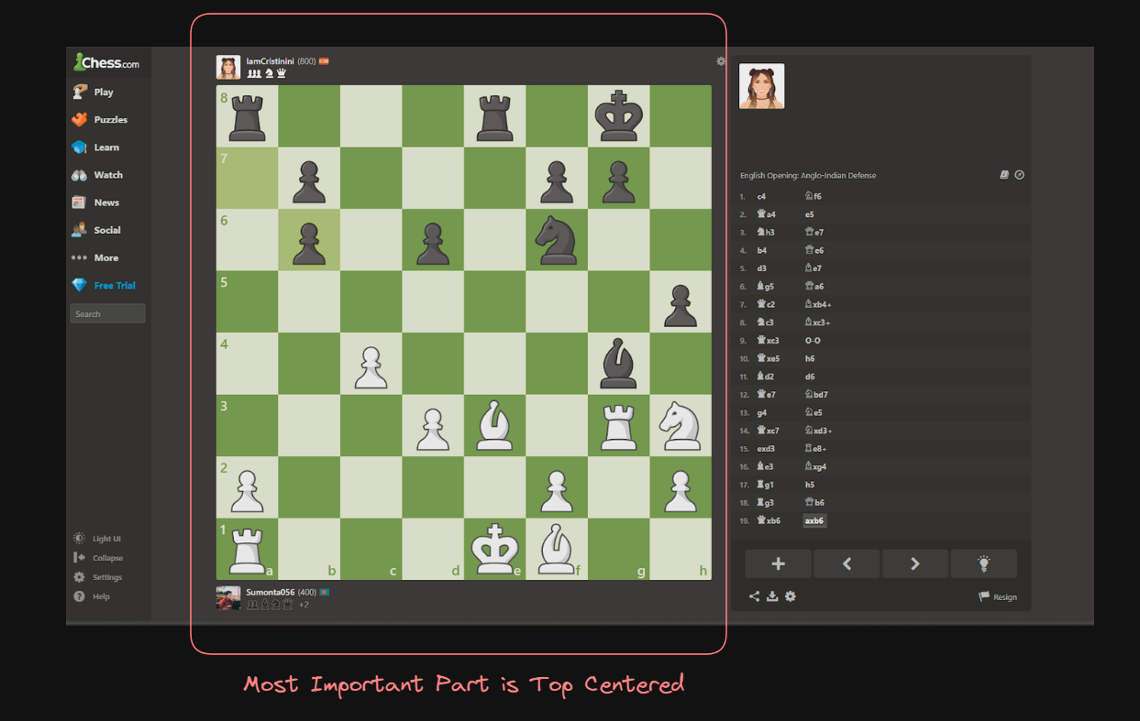

1. **Place important items consistently: *Rating: 9.5/10***
   1. Important actions or information are consistently located across the website to help users find them easily.
   2. Although the website has different game modes but the main section of the game is always consistent and side menu bar also remains constant for different pages. (Below Image you can see different game modes but same consistency over sections which helps users to locate and find the easily)

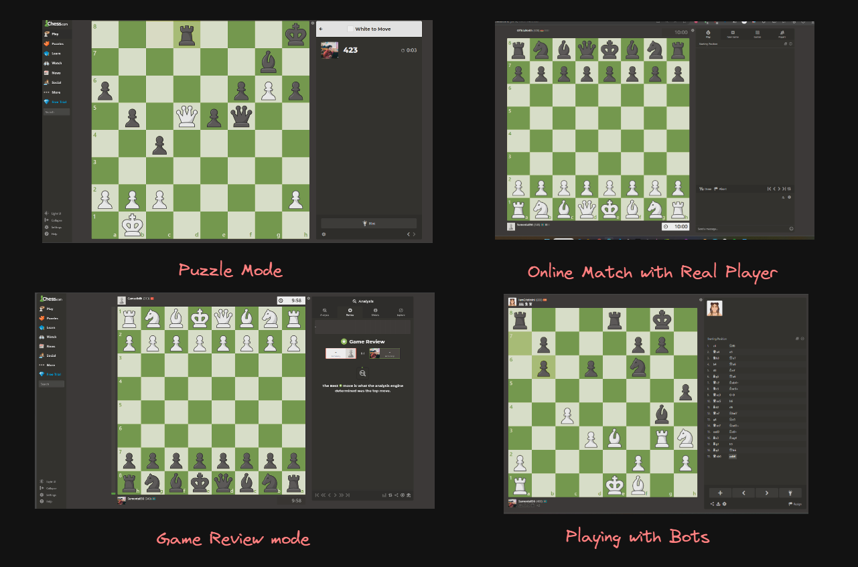

1. **Set appropriate page lengths: *Rating: 8/10***
   1. Long pages can be overwhelming and may lead to user drop-off. Ensure that content is broken down into manageable sections or pages. The Website has very few long pages mentioned above images
   2. **2 Point Cut**: The Game History Page has long sections; it would be would be 10 on 10 if the website has pagination segment for this page.

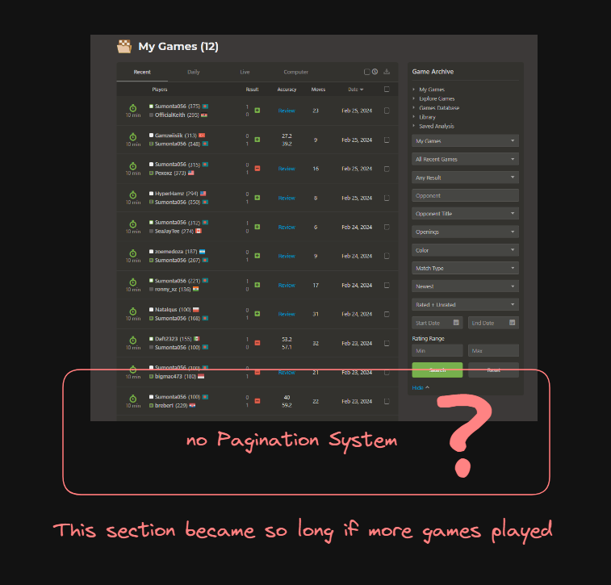

1. **Minimal input actions by the user: *Rating: 9/10***
   1. The website is design as few actions from the user as possible, especially for common tasks.
   2. To Play user do not need to navigate to through many pages. They can play directly any game modes directly from home which helps taking them few action for completing task

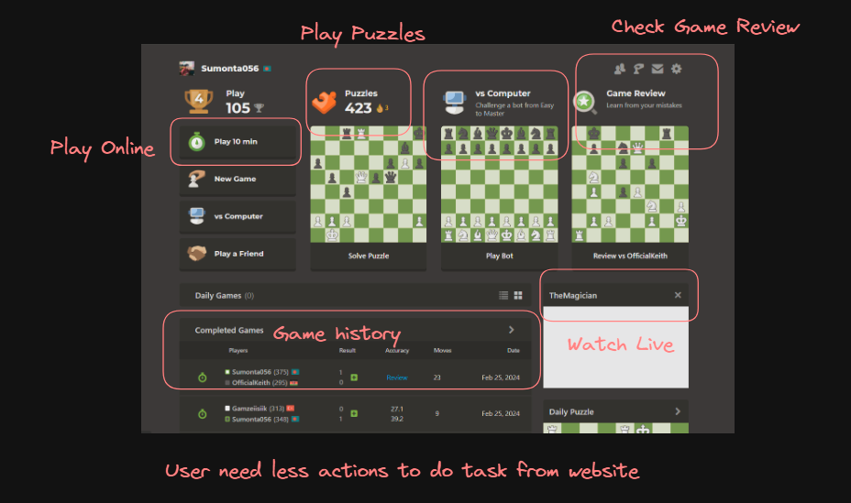

1. **Make all functionality available from a keyboard: *Rating: 2/10***
   1. Almost nothing is a functionable with keyboard
   2. User Must Need Mouse for playing Games
   3. 2 points: Just Some of menu key are accessible with Tab key

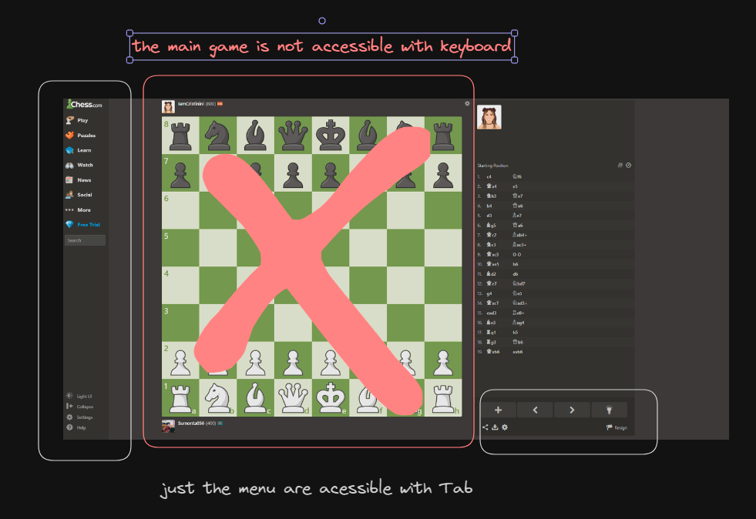

1. **Clear and effective labeling of buttons and data-entry fields: *Rating: 9/10***
   1. Website has clear, descriptive labels for buttons and fields to ensure users understand what each element does. Almost All buttons and entry field have proper labeling (Fig – 1,2)
   2. **1 Point Cut:** There are two buttons which don’t have labeling before clicking on it (Fig – 3)

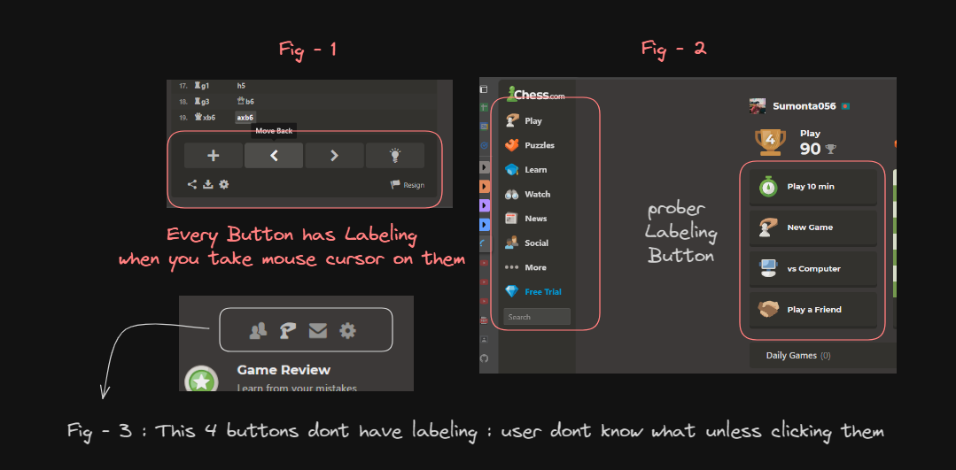

1. **Compatibility of data entry with data display: *Rating: 9/10***
   1. When users enter data, ensure that it is displayed in a way that makes sense and matches the entry format.
   2. User can visualize their move and also and text formatted table in left side of screen showing their moves

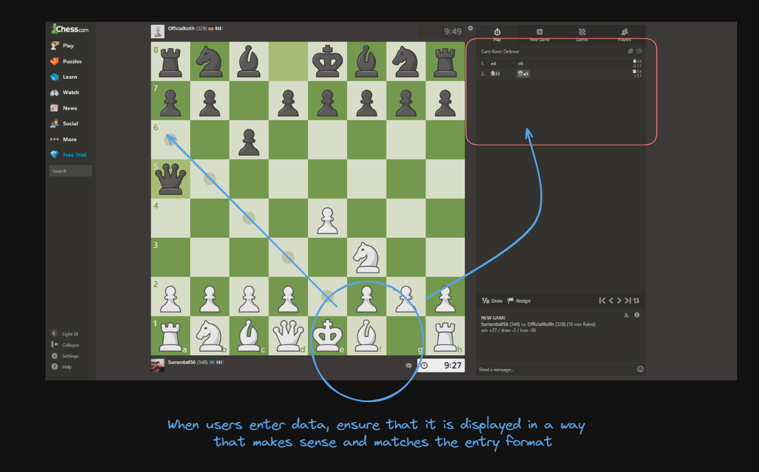

1. **Do not use content that causes seizures: *Rating: 1/10***
   1. The Website provides or shows contents that triggered users
   2. **6 Point Cut:** Show ad in home screens and Playing games where distraction is not allowed
   3. **3 Point Cut:** Sometimes in review section “Ad To view membership pop ups”

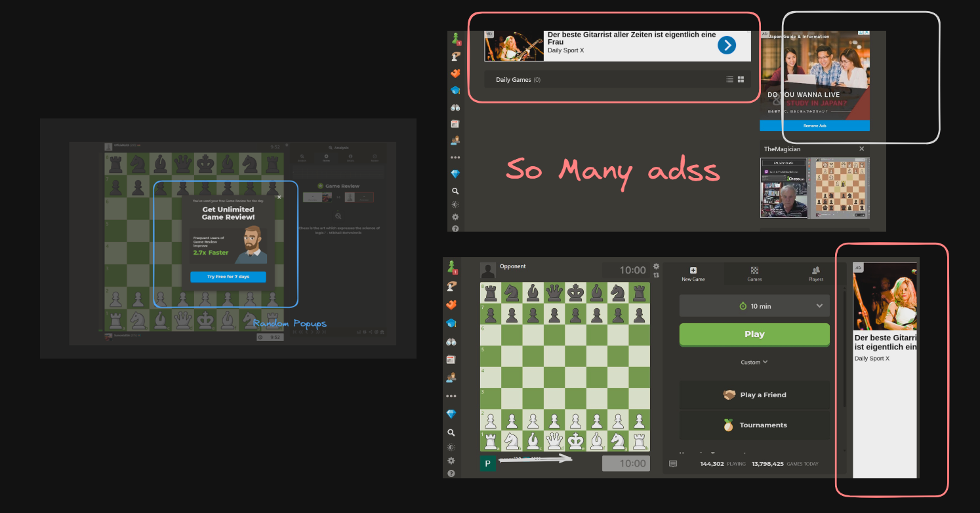

1. **Give users enough time to read and use content: *Rating: 10/10***
   1. Website Pages and Elements don’t need immediate action or response.
2. **Design of form and dialog boxes: *Rating: 9/10***
   1. More user friendly and Minimalistic design

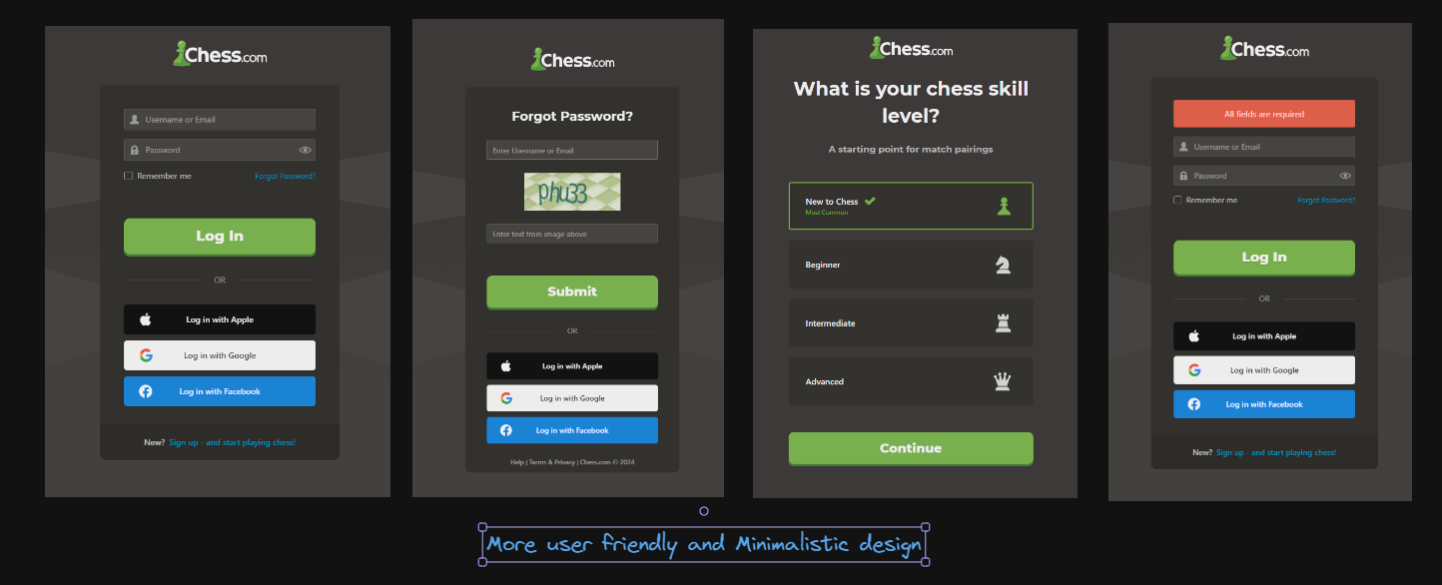

1. **Help users navigate and find content: *Rating: 6/10***
   1. Although website is easy to understand and everything is noticeable
   2. **4 Point Cut:** When a new user comes, they need to find and understand everything on their own. Theirs is no tour and guide system for first time

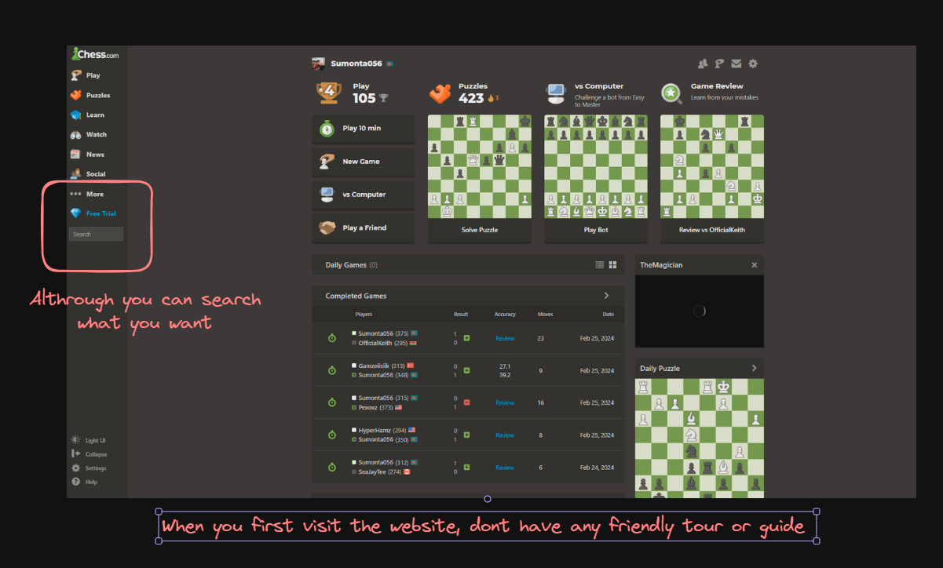

1. **Help users navigate and find content: *Rating: 9/10***
   1. Provide error messages and feedback that help users correct their actions.
   2. Website Has Features Like “Game Review + Mistakes on move + Teach Them”

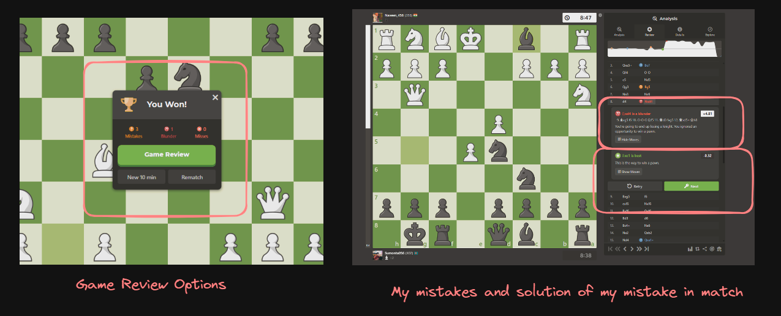

1. **Maximize compatibility with current and future user tools: *Rating 9/10***
   1. Ensure that the website follows widely accepted web standards
   2. Compliance with standards ensures compatibility with a wide range of browsers, devices, and assistive technologies both now and in the future.
   3. Responsive Design adapts seamlessly to various screen sizes and resolutions.

